Adult Day Program at Four Counties Health Services

Four Counties Health Services (FCHS) in Newbury has been providing the Adult Day Program (ADP) since 1987, with over 1,100 client visits in 2015. This program helps to support seniors and adults with disabilities who live independently in the community. It also provides respite to family caregivers. A client of the program recently noted “ I have been looking for quite a while for a program like this where there are happy people, communicating with each other, having fun. I would miss the program and staff if I didn’t attend.”

Better known as “The Sunshine Club”, the Four Counties ADP operates Wednesdays, Thursdays and Fridays from 10am to 3pm for clients wishing to attend. We offer an opportunity for a day away in a safe and caring community setting to socialize, interact and make new friends. At the modest cost of $10/day, the program provides a variety of social, educational and recreational activities including: supervised exercises, fun and stimulating games, cards & crafts, entertainers & musical programs, special events, current event discussions & guest speakers, intergenerational programs, as well as a hot meal and snacks.

FCHS partners with the South West Community Care Access Centre (SW CCAC) for referrals to the program. To participate in this program, individuals can call the FCHS Adult Day Centre Coordinator, Lin McCann at (519) 693-7111 Ext 2443. Transportation to and from the program can be arranged (for a small fee) via Four Counties Transit.

“The Adult Day Program is a wonderful program which contributes to the vitality and vision of Four Counties Health Services and its role as a ‘health village’ in the community. We appreciate our partnership with SW CCAC in providing the best possible care for the clients we serve,” says Steph Ouellet, Vice-President, Strategic Partnerships at Middlesex Hospital Alliance and FCHS Site Director.

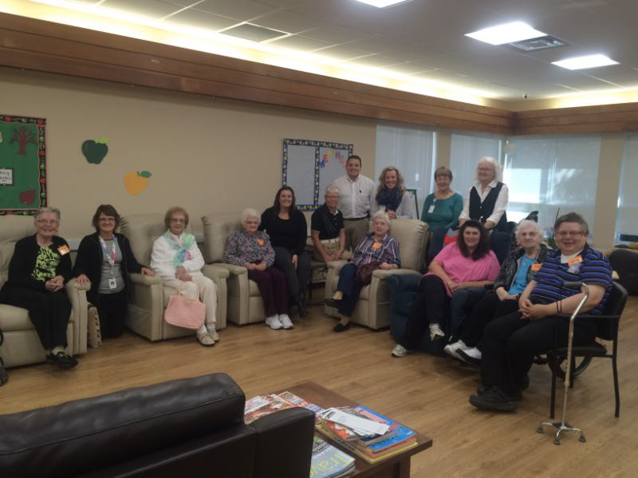

The Sunshine Group at FCHS

