**October 15, 2015**

For more information   
contact:

**Todd Stepanuik**  
President & CEO  
519 245-5295, #5592

or visit our website:

[www.mhalliance.on.ca](http://www.mhalliance.on.ca)

MEDIA RELEASE

For Immediate Release

***Adult Day Program celebration at***

***Four Counties Health Services***

**(Newbury, ON) –** October is Community Support Month across Ontario. Four Counties Health Services (FCHS) is celebrating Adult Day Program week from October 11th -17th. FCHS has been providing the Adult Day Program (ADP) since 1987, with over 1,100 patient visits in 2014. This program helps to support seniors and adults with disabilities who live independently in the community. It also provides respite to family caregivers.

Better known as “The Sunshine Club”, the Four Counties ADP operates Wednesdays, Thursdays and Fridays from 10am to 3pm. At the modest cost of $10/day, the program offers fun activities, exercises, a hot meal and snacks, in addition to social interaction.

FCHS partners with the South West Community Care Access Centre (SW CCAC) for referrals to the program. We are happy to welcome Mary Ducharme as our new SW CCAC Care Coordinator for Middlesex County. “I look forward to working with FCHS, along with its current and future ADP clientele”, says Ms Ducharme.

To participate in this program, individuals must have a referral which is provided through the CCAC. The SW CCAC can be reached by calling 1-800-811-5146 or Seniors Health Services at 519-310-2222, or by contacting the CCAC in your area. Transportation to and from the program can be arranged (for a small fee) via Four Counties Transit.

“The Adult Day Program is a wonderful program which contributes to the vitality and vision of Four Counties Health Services and its role as a ‘health village’ in the community. We appreciate our partnership with SW CCAC in providing the best possible care for the clients we serve,” says Steph Ouellet, Vice-President, Strategic Partnerships at Middlesex Hospital Alliance and FCHS Site Director.

For additional information specific to the Adult Day Program at Four Counties Health Services or to arrange for a tour, please call Lin McCann, ADP Coordinator, at 519-693-7111 ext. 2443.

Join our “Sunshine Club” and make new friends!

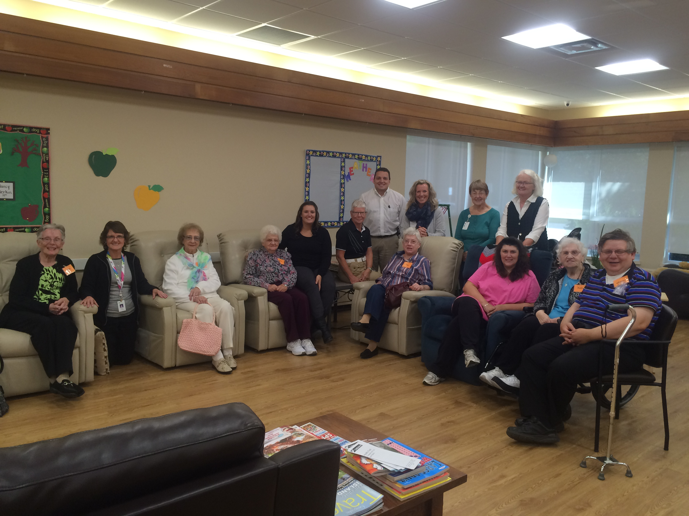

Pictured at a recent “Sunshine Club” day are:

Barb Crowell, Mary Ducharme-CCAC Care Coordinator, Dorothy Pringle, Helen Tyrell, Patti Hart- ADP Assistant, Lin McCann-ADP Coordinator, Steph Ouellet- FCHS Site Director and VP of Strategic Partnerships, Linda Dunn-Manager of Community Support Programs, Lillian Cameron and Loretta Johnson- Program Volunteers, Anne Goens, Tammy Cartlidge-Program Assistant, Cathy Long and George Lupsor.

About MHA:

The Middlesex Hospital Alliance (MHA) is comprised of two fully-accredited partner sites: Four Counties Health Services and Strathroy Middlesex General Hospital.

A progressive, team-oriented and technologically adept organization of excellence, the MHA is creating a more integrated and seamless approach to treatment by embracing and seeking out partnerships, through collaboration and investing in people. This coordinated approach helps to ensure that a high level of service is provided while reducing costs and continually enhancing quality.

Providing core acute primary and secondary hospital care, the MHA has also been recognized for establishing two notable Centres of Achievement (Orthopaedics and Diabetes Education Centre) that generate local and regional referrals.

- 30 -