**August 30, 2018**

For more information   
contact:

**Alasdair Smith (MHA)**

VP Finance/CFO  
519 245-5295, Ext. 5504

Or

Renee Leventhal (Dynacare) Director of Physician Relations

[1-800-](http://www.mhalliance.on.ca)669-2714, Ext. 5350

MEDIA RELEASE

For Immediate Release

***Community Lab Services – Dynacare***

***Collection Centre***

(Newbury, ON) - The Four Counties Health Services (FCHS) is pleased to announce that Dynacare will be establishing a specimen collection centre, for community lab work, at the FCHS. Community lab work includes tests that are ordered by Family Physician, Nurse Practitioner or Specialist private offices. The development of this lab collection centre is in keeping with, and supportive of, the Health Village model that the MHA envisions for the FCHS campus.

Effective Monday, September 10th, Dynacare will go live with their community lab specimen collection centre at the FCHS site. For a 4-month transition period, the Dynacare collection centre hours of operation will be **Monday through Thursday, from 8:00 AM to 1:00 PM**. “We’re proud to provide access to healthcare solutions in Newbury”, said Renee Leventhal, Director of Physician Relations at Dynacare. “Our partnership with Four Counties Health Services will allow us to help improve the overall health and wellness of the community”.

The FCHS Lab will be focused on the services required for the FCHS ER, Ambulatory Care and Inpatient Unit. Any community lab patients who present to the FCHS Lab area will be redirected to the Dynacare location.

During the 4-month transition period, the FCHS Lab will perform blood draws on Fridays. Members of the community will experience no change in their ability to get bloodwork drawn other than the new location within FCHS. “We are very happy to have re-established Dynacare’s presence on the campus so that we can ensure that the community continues to have access to services”, said Alasdair Smith, VP-Finance for the Middlesex Hospital Alliance. “This allows us to focus on the Hospital’s range of services and lets Dynacare focus on the wider community lab service”.

Signage will be installed to help direct patients to the Dynacare location. Access through the “Main Entrance” is the easiest route. Please refer to the map, attached.

Dynacare will be meeting with local and regional Physicians and Nurse Practitioners over the next few weeks to introduce the change to this service.

Both partners are committed to working to ensure the new venture’s success for patients, and their primary care practitioners.

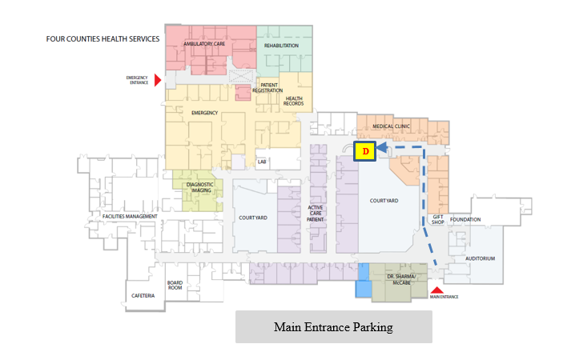

Dynacare Collection Centre

* Accessed through the Main Entrance
* Follow the corridor straight ahead
* Turn left at the end
* Monday/Tuesday/Wednesday/Thursday 8 AM to 1 PM

About MHA:

Four Counties Health Services is part of the Middlesex Hospital Alliance. FCHS is a primary care facility that has been providing 24-hour Emergency care, diagnostic and therapeutic services and inpatient care for over 50 years. Serving approximately 23,000 residents, it is located in the village of Newbury at the intersection of Lambton, Kent, Middlesex and Elgin Counties. It serves a rural population comprised of villages, hamlets and farm communities.

About Dynacare:

Dynacare has been providing health and wellness solutions for more than 50 years, with innovative and accessible laboratory testing facilities located in Ontario, Quebec, Manitoba, Alberta, and B.C. As a valuable community-healthcare partner, Dynacare provides access to flexible collection sites, innovative scientific testing, and comprehensive clinical support. Over 1,500 tests are available as part of an extensive menu that features the newest technologies in specialized diagnostic testing.

-30-