Ebola myths: 5 assumptions that aren't true

Humans 'fear the least likely outcome,' says medical expert
CBC News Posted: Oct 21, 2014 5:00 AM ET Last Updated: Oct 22, 2014 5:57 AM ET
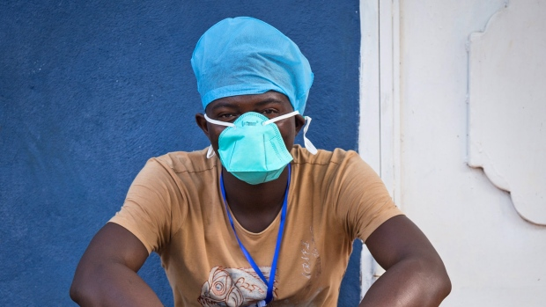

The current Ebola outbreak has claimed the lives of more than 4,000 people in west Africa, but medical experts say it has also created a pandemic of anxiety and misinformation here in North America.

"This reminds me of AIDS — the fear, the panic, the lack of understanding among us," says Lin Weeks-Wilder, a former medical director at both the Texas Medical Center and the University of Massachusetts Medical Center.
Late last week, Reuters reported that a Texas college had denied the applications of two students from Nigeria because of Ebola — this despite the fact that the west African nation has actually been the first country to contain the virus outbreak.
Weeks-Wilder acknowledges that when a medical crisis like this emerges, humans tend to "fear the least likely outcome and ignore the things we need to worry about."
Here's a look at myths surrounding the current Ebola outbreak.

Myth #1: Anyone who returns from west Africa with a fever or a cough has Ebola.
So far, there have been three verified Ebola cases in North America — one of which was Thomas Eric Duncan, who became infected in Liberia and then travelled to the U.S., where he has since died.
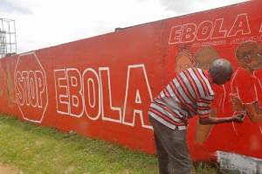
This has not only led to concern about the safety of air travel, but also a widespread assumption that anyone arriving from Africa with a cough or an elevated temperature has Ebola.
This is just not the case, says Dr. Todd Hatchette, director of virology and immunology at Dalhousie University in Halifax.
"At the present time, most of the people who return from Africa with a fever don't have Ebola — they have something more common, like malaria," says Hatchette.

Myth #2: The Ebola virus is, or will become, airborne.
Dr. Michael Gardam, director of infection prevention and control at the University Health Network in Toronto, points out that the virus was discovered nearly four decades ago and has never shown any ability to spread by air the way that SARS (severe acute respiratory syndrome) can.
He emphasizes that Ebola "is very hard to catch."
"All the epidemiology that we know from 1976 on says there is not any major form of airborne transmission of Ebola — if there was, we'd all be dead," says Gardam.
"You have to take a big step back and look at it logically and see that [airborne transmission] really can't be the case."
As the World Health Organization states, the virus can only be transmitted through “close and direct physical contact with infected bodily fluids.”
The main ones are blood, feces and vomit, although urine, semen, saliva, breast milk and tears can also be infectious

Myth #3: Contracting Ebola is an automatic death sentence.
While some media outlets have reported that Ebola's mortality rate is 90 per cent, that figure is actually the upper range, says Weeks-Wilder.
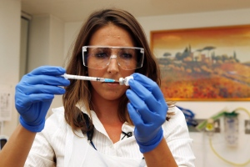
A number of countries, including Canada, the UK and Russia, are currently developing an Ebola vaccine, but none of them have been tested yet. (The Associated Press)
"If you look at the mortality rates of Ebola, it varies between 20 per cent and 90 per cent — that's a really wide variation," she says.
Gardam says the numbers are skewed by geographic factors, emphasizing that "the mortality rate is very high in countries that have no health-care system," such as those in the western African nations of Guinea, Sierra Leone and Liberia.
Not only that, patients there often delay visiting hospitals until they are in the advanced stages of the disease, he says.
The situation is significantly different in North America, which boasts world-class medical facilities and is well-equipped to deal with any Ebola cases, says Gardam.
"It's still going to have a significant mortality rate [if it comes to North America], but I would be shocked if it stayed at 70 to 80 per cent. I would think it would drop to 10 to 20 per cent, at which point it's in the realm of SARS."
According to the U.S. Centers for Disease Control, if an exposed person does not become ill after 21 days, "they will not become sick with Ebola."

Myth #4: All Ebola victims bleed from the eyes and ears.
Not every patient gets the profuse bleeding that "everybody worries about," says Hatchette.
He points to a report in the New England Journal of Medicine looking at symptoms exhibited in the current Ebola outbreak in western Africa. The research found that only 18 per cent of infected patients showed signs of "unexplained bleeding."
Ebola used to be called a hemorrhagic fever virus, but Gardam says WHO stopped using that wording "because they realized that the vast majority of [Ebola patients] don't hemorrhage."
Gardam says that "a lot of that is medicine's own fault for calling it that, and the other half of that is Hollywood, where it makes really good copy to have somebody bleeding out of their eyeballs."

Myth #5: There's an effective vaccine, and we just need to get it to the people who need it.
There are a number of promising Ebola vaccines, says Gardam, including one being developed at the National Microbiology Laboratory in Winnipeg and one in Russia.
The Public Health Agency in Canada recently donated 800 to 1,000 vials of the Canadian vaccine to the WHO, which will begin clinical trials on it in late October or early November.
Gardam cautions that none of the vaccines has been proven effective, which is why the WHO is proceeding cautiously.
The organization hopes that by early December, it will know whether the Canadian vaccine has any potential side-effects. Regardless, it will be months before it could be readily available.
"The challenge with vaccines is you can't always assume they're going to work in humans, and there are some circumstances in medical history where they made [things] worse," says Gardam.
"That's why the WHO was spending so much time on those ethical discussions regarding whether we should be doing this or not, and they came down on, well, we should try this. But it's not a slam dunk."

