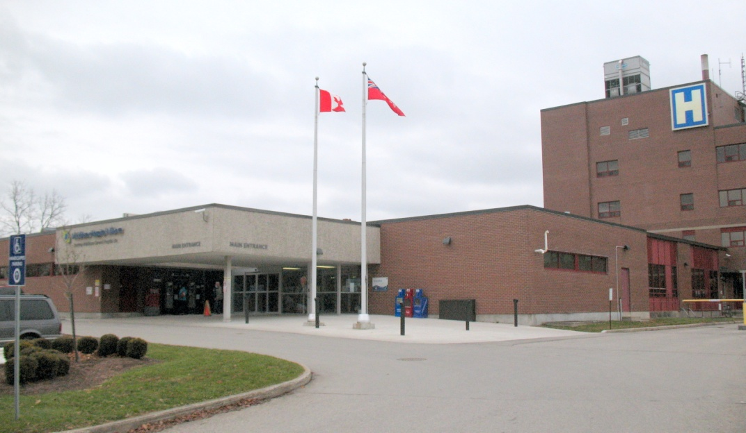

STRATEGIC ENERGY

MANAGEMENT PLAN FOR

MIDDLESEX HOSPITAL ALLIANCE

2019 - 2023

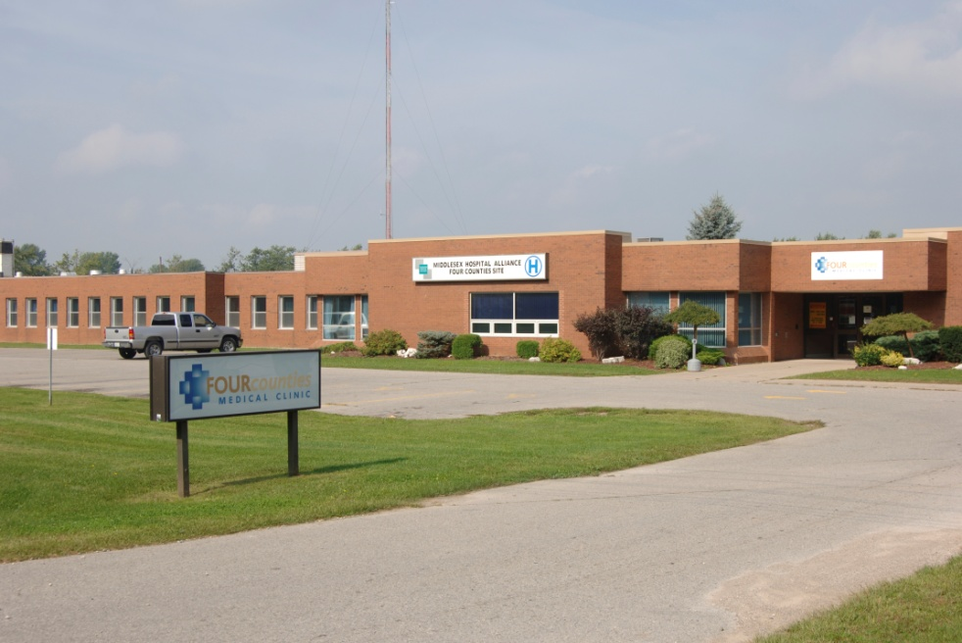

*Approved by,*

Todd Stepanuik

President & Chief Executive Officer

Middlesex Hospital Alliance

*Submitted by,*

Ryan Whitney

Manager –Maintenance Services, Facilities Management

Middlesex Hospital Alliance

##### 

## Introduction

The purpose of Middlesex Hospital Alliance’s energy management plan and policies is to promote good stewardship of our environment and community resources. In keeping with our Strategic Pillar (Resources), Middlesex Hospital Alliances’ energy management program will strive for a modern and efficient infrastructure, pursue operational efficiencies, and set a strong financial foundation.

The following data is an update for 2019 of the Energy Data for 2018 submitted as part of our requirements under the Green Energy Act. We have also included updates to our 2019 Strategic Energy Management Plan Timeline where applicable.

Background from the 2014-2018 Plan

* + - With energy management an integral part of business decisions, Middlesex Hospital Alliance can expect the following:
* 3% reduction in energy consumption, with an overall reduction of 10% in utility costs
* $200,000 in savings annually to the bottom line (2 million over 10 years) via ESCO (“Energy Savings Company”)
  + - Recent activity associated with managing these costs include the following
* Increased awareness and monitoring of energy use and costs
* OHA Hospital Scorecard survey participation and benchmarking report
* Completed RFP for an Energy Partner
* Implementation of Energy Performance Review with Proposed Firm
* Participation in Energy Star Portfolio Manager – Under Review
* Participate in saveONenergy Programs with both Entegrus and Union Gas
  + - To further strengthen and obtain full value from energy management activities, a strategic approach will be taken: the organization will fully integrate energy management into its business decision-making, policies, and operating procedures.
    - Active management of energy related costs and risks in this manner will provide a significant economic return to the organization and will support other key organizational objectives.

## 

## Energy Management Vision

The Middlesex Hospital Alliances’ mission is “To provide the healthcare we would expect for our own families”. This mission coupled with our vision of “Exceptional Care by Exceptional People” drive our commitment to energy management as a critical component of our success.

We at MHA consider our facilities to be an integral part of the patient experience and a direct link to successful patient outcomes. The efficient and effective operation of our facilities allows the resources to be applied to patient care and promotes our ability to achieve our mission. Environmentally we are also able to reduce our waste, control our emissions, and effectively reduce our carbon footprint to ensure an improved patient experience and also to create a healthier environment for everyone in our community. It should be noted that the Utilities budget ($758,229) represented 43% of the annual Facilities budget (2018-19) and is also a significant item in the overall operations budget for MHA.

The MHA energy management vision is to ***“Identify, Monitor and Reduce Waste, wherever possible, through education, infrastructure improvement, policy and process changes, and embrace a culture of sustained energy stewardship”.***

## Guiding Principles for Strategic Energy Management

Middlesex Hospital Alliance’s energy management will be guided by these principles:

*Taking a Strategic Approach:* Middlesex Hospital Alliance actively manages energy costs by implementing opportunities as they are identified and within a limited budget envelope. By acting strategically, MHA can improve its energy-related performance. Internalizing energy management into our organization’s day-to-day decision making, policies, and operating procedures will help ensure long lasting reductions in energy use throughout MHA.

***Supporting Mission-Critical Goals:*** Strategic energy management supports the Middlesex Hospital Alliance’s goals of delivering timely access to patient care services, meet or exceed established quality benchmarks, invest in our people in accordance with our principles and purpose, provide a safe environment for patients and people, and to ensure fiscal responsibility. The impacts of Middlesex Hospital Alliance’s energy management efforts on those goals are reviewed using annual energy usage to determine positive outcomes.

*Pursuing Long-Term Change to Core Business Practices:* The core of a strategic approach is the consistent incorporation of energy management into our organization’s strategic planning and budgeting processes. Change in energy-related business practice will cover all applications of energy management – new construction and major renovations, existing facility operations and upgrades, and the economic analysis and procurement practices underlying these practices.

***Fostering Organizational Commitment and Involvement:*** Executive and organizational commitment and involvement is critical to successful strategic energy management. Senior management at Middlesex Hospital Alliance will work with facility managers and other key staff to ensure that adequate organizational support and resources are provided to maximize the benefits of energy management. Middlesex Hospital Alliance energy management will be integrated into the strategic planning and capital budgeting processes.

***Obtaining Solid Economic Returns:*** Energy management investments will yield economic returns that meet Middlesex Hospital Alliance’s standard requirements applied through the hospital’s capital budgeting process. Middlesex Hospital Alliance will apply consistent financial analysis methods that consider life-cycle to reduce total cost of facility ownership and operation

***Using Available Resources and Assistance:*** Middlesex Hospital Alliance will use all available sources of strategic, technical, and financial assistance to help achieve our energy management goals. These include programs through local distribution companies, the Ontario Power Authority, ENERGYSTAR, saveONenergy, the Canadian Coalition for Green Health Care, The Canadian Healthcare Engineering Society and EnerCan.

## The Business Case for Strategic Energy Management

Below are the central business arguments for Middlesex Hospital Alliance’s pursuit of strategic energy management. Section VI then presents the business proposition – the results of analysis of the energy efficiency opportunities and their associated costs and internal rate of return.

***Strengthened Community Leadership and Environmental Stewardship***

Energy management is a visible, public commitment to the community and environment. Through aggressive energy management, Middlesex Hospital Alliance can provide leadership in promoting sustainable communities, efficient business practices, and environmental stewardship. This is an excellent opportunity to provide leadership and reduce costs at the same time.

***Enhanced Healing and Working Environment***

In existing facilities, efficient operating practices improve patient as well as employee comfort with more stable air temperature, and better indoor air quality and lighting.

***Improved Financial Health and Operating Cost Reduction***

Strategic energy management presents an opportunity to reduce operating costs and positively impact Middlesex Hospital Alliance’s bottom line.

Operating cost savings directly improve the hospital’s operating position. Further, investments in energy projects typically have a lower risk of performance over time relative to other investments and savings from energy projects are easier to forecast than savings or revenue increases expected from more variable types of investment.

***Optimization of Capacity to Meet Current and Expanding Operational Needs***

Energy efficiency optimizes inefficient or poorly designed and operated equipment/systems so wasted energy system capacity can be reclaimed for current and expanding operational needs. This “free capacity” can eliminate the need to add major new energy capacity and be much less expensive.

## Business Proposition 2014

* If energy management considerations are integral to relevant business practices, policies, procedures, and decision making processes the Middlesex Hospital Alliance’s energy-related costs can be reduced by an *additional* 10% over a 10-year period.
* Middlesex Hospital Alliance will invest up to $3 million in energy related capital and operating improvements, funded directly through guaranteed energy savings of $200,000 annually over the next 12-year period (2014-2026).
* Utilizing an Integrated Decision making process, MHA will consider energy conservation and environment equally when selecting future capital projects

Outcomes 2014-2018

* MHA has improved its Energy policies and processes including the following:
  + Reviewing Equipment purchases to meet EnerGuide ratings
  + Requiring Engineering to use Energy Efficient designs (e.g., LED lighting)
  + Updating the Building Automation System and providing training to staff on its use
  + Actively seeking grants for Energy Projects
* MHA completed a review of potential energy savings initiatives with an Energy Savings Company (ESCO). The review determined that an implementation of the work via this proposed contract would not be positive for MHA and it was decided not to continue the relationship.
* During the 2014-2018 period MHA completed a significant amount of HIRF (Hospital Infrastructure Renewal Fund and Hospital Infrastructure Renewal Grant) projects. During this work MHA has included improvements in facilities and used the goal of improved energy efficiency as part of the design criteria. The primary reasons for the projects were the failure or impending failure of the systems and their inefficiency.
* During 2017 the Government introduced the Hospital Energy Efficiency Program (HEEP). MHA was able to leverage several projects that were specific to energy efficiency while at the same time updating old run-down infrastructure. This program was discontinued in the 2018/19 fiscal year.
* During 2014-2018 MHA also implemented capital projects using Energy Efficiency as one of the design elements. For instance, projects have implemented the use of LED lighting and the use of the most energy efficient HVAC updates where possible. New Patient Care equipment is reviewed for use of Energy Star rated units where possible.
* During the period 2013-2018 MHA has made significant strides in energy reduction (consumption). The chart below shows the progress over that timeframe.

|  |  |  |
| --- | --- | --- |
|  | **PERCENT REDUCTIONS 2013 vs 2018** | |
|  | **SMGH** | **FCHS** |
| Hydro | 9% | 20% |
| Gas | 8% | 9% |
| Water | 69% | 8% |

## HIRF/HEEP Projects that have impacted Energy 2014 thru 2018

1. Replacement of AHU#4 at FCHS -- A new energy efficient Air Handler was installed in 2015-16 with improved controls
2. FCHS Controls -- The old control system was updated in 2016 with new Direct Digital Control allowing better control of HVAC systems.
3. SMGH Controls -- The old control system was updated in 2016 with new Direct Digital Control allowing better control of HVAC systems.
4. DCW/DHW Piping -- A renewal of the Hot and Cold water piping system at SMGH was completed in 2015 resulting in 26130 cubic meter saving in water use ($57,930) .
5. SMGH Cladding -- New exterior Cladding was completed in 2015 improving the insulation value of the facility.
6. SMGH Boilers -- New Heating boilers were installed in 2016 with a 20% improvement in efficiency
7. SMGH/FCHS Medical Air & Vacuum Pump -- The pumps where replaced with new efficient units resulting in water and hydro savings.
8. FCHS/SMGH – The start of a roofing replacement program in 2017 at both sites has resulted in a portion of the roof with more energy efficiency
9. AHU#3 – FCHS -- A new energy efficient Air Handler was installed in 2016-17 with improved controls
10. SMGH – A new Cooling system for the OR’s was installed with new controls in 2017.
11. The SMGH old Cooling Tower was replaced in 2017 with a new unit utilizing VFD fans and precise controls to improve efficiency.
12. The SMGH Kitchen Exhaust system was install in 2018 with new controls to improve efficiency
13. Air Compressors at both sites where replaced with energy efficient models in 2018
14. The replacement of #700 Air Handler that serves the DI/OR area at SMGH in 2018-19 with a new unit using VFD and Building Automation control technology for improved efficiency will reduce energy usage.
15. Outdated Exterior Lighting at FCHS was replaced in 2018-19 with LED technology.
16. As part of the HEEP program at FCHS a significant amount of the interior old-style light was converted to LED
17. Two RTU (Roof Top Units) HVAC systems where replaced with new efficient units at FCHS as part of HEEP
18. At SMGH, the first phase of an interior lighting upgrade to LED took place utilizing the HEEP funds

Save on Energy 2014-2018

MHA has been working with both Union Gas and Entegrus to obtain Energy Incentives thru the Ontario Government “Save on Energy” program.

In total MHA completed 15 projects and submitted 12 projects for review by Union Gas and Entegrus. This resulted in over $30,000 in incentive grants to date.

**Energy Awareness/Awards Programs 2014-2018**

MHA participated in two major energy awareness programs. The first was the Ontario Regulation 397/11 Energy Conservation annual reporting each year in July. Currently MHA have posted the required results for 2011 thru 2017 on both the Government and the MHA web sites.

The second program is the Green Hospital Scorecard from OHA (greenhealthcare.ca) which uses the Energy and Waste Management reporting to rank individual Hospitals to both their peer hospitals and all Hospitals in Ontario. MHA has participated from 2014. MHA has achieved at the Bronze Award level compared to other hospitals. MHA has had Energy Usage and Energy Intensity better than both peer and All Hospital group submissions during this period.

In 2018 FCHS was the TOP Performer in Small Hospitals for Water usage in 2017 and was recognized with this award certificate at the annual OHA conference.

## Energy Management Goals 2019 - 2023

The following outlines some of the Strategic Energy Management Plan new and continuing goals that are used by the Middlesex Hospital Alliance. They include, but are not limited to, the following:

#### Goal: SEMP Approval, Resources to Implement

* Executive approval, process adjustments and resource allocation to support initiatives.
* Support from key staff (financial management, purchasing/procurement, construction, building operations, etc.).
* Review of mechanisms/processes to make resources available.
* Clarification and communication of staff roles and responsibilities, performance goals, and energy management reporting.

#### Goal: Implement Financial Practices and Decision Making Processes

* Money spent to achieve energy efficiency is viewed as an investment, not a cost.
* Financial decision makers consistently use life cycle cost analysis (LCCA) on all new construction, major renovations, and equipment replacements in addition to lowest cost option.
* Staff are trained on life cycle cost analysis, financial requirements and the decision making process.
* Decisions about energy management investments are part of Middlesex Hospital Alliance’s high-level, long range process of budgeting for capital and operations.

#### Goal: Implement Strategic Energy Management Practices

Establish Purchasing Specifications for Energy Efficient Equipment and Services

* Establish new and consistently use existing purchasing specifications that minimize life-cycle costs for energy efficient equipment and services.
* Use/Establish efficiency specifications for standard equipment routinely replaced (e.g. lights, motors, and unitary HVAC equipment).
* Use/Establish efficiency guidelines that apply LCCA for custom equipment purchases (e.g. chillers).
* Use/Establish efficiency standards for design and construction, and for building operations and maintenance services.

#### Enhanced Design & Construction (D&C) Practices

* Use improved new construction practices in all capital projects that specify early team collaboration and “integrated design” (ID).
* Integrated design required for funding.
* RFPs, contract terms & conditions, & fee structures will support ID.
* Apply LCCA and financial hurdle rates described above to design decisions.
* Apply established purchasing procedures and specifications.
* Include incentives and tax credits wherever available.
* Educate all MHA project managers or construction managers and contractors on integrated design and their respective roles in master planning pre-design, design, construction, testing, commissioning, and monitoring.

#### Enhanced Facility Operating Practices

* Set and meet clear energy performance targets for new build projects; measure and improve over time.
* Establish baseline for measuring performance goals (e.g., code, or national reference standards like ASHRAE 90.1).
* Set targets, measure performance and strive for improvements over time.
* Specify commissioning as a standard procedure.
* Ensure that all building systems and elements will be designed, installed, and calibrated to operate as designed.
* All involved contractors will work closely throughout the design process and occupancy to ensure good transition.
* Improve Building Operating Performance through Facilities Staff use of Controls and ongoing efforts to optimize operation of HVAC systems
* Equipment tune-up and improved operations and maintenance (O&M) will achieve the following results while supporting patient care, and facility comfort and safety.
* Achieve reductions in operating costs for existing facilities and continue to improve these metrics.
* Use Building recommissioning to continue to improve operations and reduce energy usage
* Improve OHA Green Scorecard rating to the Silver level by 2022 in its Peer Group.

#### Cost-Effective Facility Upgrades

* Implement equipment and system upgrades where justified by life-cycle cost analysis.
* Expand use of qualified service providers as needed. Develop standard RFP documents, contract terms, and reporting standards.

#### Actively Manage Energy Commodity

* Minimize utility costs and exposure to market risks. Utility costs include natural gas, electricity, water, and sewer.
* Participate in the energy/utility regulatory process.

#### Goal: Monitor, Track, and Reward Progress

* Track progress on Strategic Energy Master Plan
* Track energy reductions monthly and report annually
* Participate in Award/Recognition and monitoring programs such as Green Hospital Scorecard
* Provide energy monitoring information to Government and Public thru online support of the Energy Reporting requirements.
* Reward staff for successes.

## Annual Energy Consumption Data 2014-2018

Consumption values are shown as a gauge of operation from year to year. As improvements to equipment and facilities operational processes have been implemented consumption can be used to indicate an energy improvement and its sustainability. When reviewing consumption other factors such as Clinical changes, number of procedures and weather all impact the overall consumption and are reviewed when determining final success of facility changes.

**2019-2023 Future Plan**

MHA will continue to update the Infrastructure of the facility using the best Energy Efficient methods and equipment possible. MHA has reviewed potential Infrastructure upgrades that would meet the funding criteria for HIRF, which is the most likely funding source. Upgrades in the following areas are under consideration as MHA receives funding support as they impact both energy usage and operational needs.

**SMGH**

* Elevators
* CB#1 steam boiler
* Remainder of all roof areas
* Distribution Systems – steam piping and condensate systems
* Remainder of interior lighting
* Walk in coolers (kitchen)
* Remainder of Air Handling Units

**FCHS**

* Remainder of roof areas
* Walk in coolers(kitchen)
* Remainder of Air Handling Units
* Remainder of Roof Top Units
* Windows
* Removal of steam boiler (update kitchen equipment)

**Timeline and Responsibilities for Plan Adoption and Implementation**

|  |  |  |  |  |  |  |  |
| --- | --- | --- | --- | --- | --- | --- | --- |
| **Measure** | **2013** | **2014** | **2015** | **2016** | **2017** | **2018** | **2019** |
| **Report energy consumption as per O.Reg 397/11** | Complete | Complete | Complete | Complete | Complete | Complete | Pending |
| **Complete an Energy Conservation and Demand Management Plan** |  | Complete |  |  |  |  | Complete |
| **Obtain approval of SEMP** |  |  |  |  |  |  | Pending |
| **RFP to select an Energy Performance Partner** | Pending | Complete |  |  |  |  |  |
| **Energy Performance Contract** |  | Pending | Pending Approval | Ongoing | New Plan |  |  |
| **Ongoing monitoring and verification of energy conservation measures** |  |  | Pending (to begin at end of installation phase) | Ongoing | Ongoing | Ongoing | Ongoing |
| **Improved awareness and communication of energy conservation** |  | Pending | Ongoing | Ongoing | Ongoing | Ongoing | Ongoing |
| **Monitor energy commodity cost** | Increased water and sewer monitoring Ongoing for Electricity and Natural Gas | Ongoing | Ongoing | Ongoing | Ongoing | Ongoing | Ongoing |
| **Track and report on SEMP** |  |  | Implement Process Update |  | Ongoing | Ongoing | Ongoing |