## EARLY POST-OP ACL EXERCISES

**Perform 3 times daily beginning on the day after surgery.**

* + *This exercise improves blood circulation in your leg*

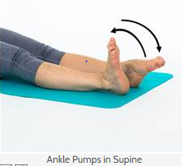

* 1. Lie on your back with both legs straight.
  2. Alternately bend and straighten your ankles, pointing toes away and then pulling them towards you.
  3. Repeat 20 times, often through out the day
  + 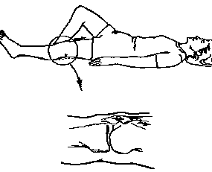*This exercise helps to strengthen your thigh muscle and straighten your knee*

1. Lie on your back with operated leg straight.
2. Tighten your thigh muscle, pushing the back of your knee down into the bed.
3. Avoid digging your heel into the bed or flexing your ankle.
4. Hold 5 seconds, repeat 10 times, 3 times per day
   * 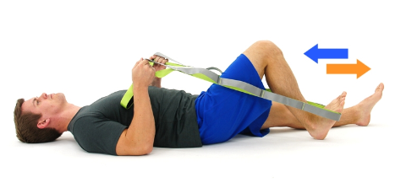*This exercise improves range of motion of your knee*
5. Lie on your back and loop a strap around your foot.
6. Slowly bend operated leg at hip and knee, sliding your heel toward buttock. Use your strap to assist.
7. Hold 5 seconds, repeat 10 times, 3 times per day

*\* This exercise stretches your calf muscle*

1. 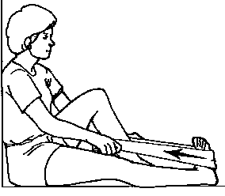Lie on your back or in sitting with leg straight out
2. Loop strap around your toes and pull them up toward your hips until you feel a stretch in your calf.

3. Hold for 30 seconds, repeat 3 times, 3 times per day

**Note: Lie down and elevate leg above heart, keeping leg straight. Place an ice or a cold pack around the operated knee after your exercises to help reduce swelling & pain**