EARLY POST-OP ACL EXERCISES

Perform 3 times daily beginning on the day after surgery.

  - This exercise improves blood circulation in your leg
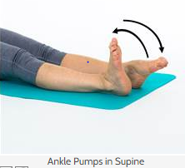

  - Lie on your back with both legs straight.
  - Alternately bend and straighten your ankles, pointing toes away and then pulling them towards you.
  - Repeat 20 times, often through out the day

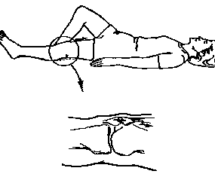
  - This exercise helps to strengthen your thigh muscle and straighten your knee

- Lie on your back with operated leg straight.
- Tighten your thigh muscle, pushing the back of your knee down into the bed.
- Avoid digging your heel into the bed or flexing your ankle.
- Hold 5 seconds, repeat 10 times, 3 times per day

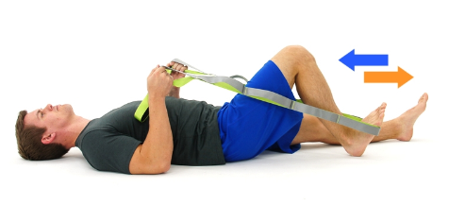
  - This exercise improves range of motion of your knee

- Lie on your back and loop a strap around your foot.
- Slowly bend operated leg at hip and knee, sliding your heel toward buttock. Use your strap to assist.
- Hold 5 seconds, repeat 10 times, 3 times per day

* This exercise stretches your calf muscle

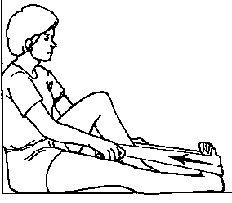
- Lie on your back or in sitting with leg straight out
- Loop strap around your toes and pull them up toward your hips until you feel a stretch in your calf.
3. Hold for 30 seconds, repeat 3 times, 3 times per day

Note: Lie down and elevate leg above heart, keeping leg straight. Place an ice or a cold pack around the operated knee after your exercises to help reduce swelling & pain

